DEVELOPMENT OF AN INTERACTIVE TOUCH APPLICATION FOR THE HP TOUCHSMART SYSTEM

IBUOMI ABIBO

A Project

Submitted to the Department of Computer Science

In Partial Fulfillment of the Requirements for

The Degree of

MASTER OF SCIENCE
IN
COMPUTER SCIENCE

PRAIRIE VIEW A&M UNIVERSITY
COLLEGE OF ENGINEERING
PRAIRIE VIEW, TEXAS

DEVELOPMENT OF AN INTERACTIVE TOUCH APPLICATION FOR THE HP TOUCHSMART SYSTEM

A Project
Submitted to the Department of Computer Science
In Partial Fulfillment of the Requirements for
The Degree of

MASTER OF SCIENCE
IN
COMPUTER SCIENCE

Submitted By:

IBUOMI ABIBO

Certificate of Approval:

_____________________________
Sherri Frizell
Student Advisor
Associate Professor
Department of Computer Science

_____________________________
Lin Li
Graduate Program Coordinator
Assistant Professor
Department of Computer Science

_____________________________
Yonggao Yang
Associate Professor & Department Head
Department of Computer Science
May 2011
ABSTRACT

Development of an Interactive Touch Application for the HP TouchSmart System.

(May 2011)

Ibuomi Abibo, B.S., Albany State University;

M.S., Prairie View A & M University

Student Advisor: Dr. Sherri Frizell

Touch-based systems are now a common feature found in daily encounters in many regions around the world and prevalent in the United States. Such can be seen from self-service gas dispensers at numerous gas stations to the automated check-out counters in department stores and even to hand-held mobile devices. These systems are made possible due to advancement and availability of software development technologies and open source software. The goal of this project is to design, develop and deploy an interactive touch application for the HP TouchSmart system. The application, Interactive Kitchen Helper, holds and displays recipes with features for adding, editing, deleting and sorting recipes. The application is built on the Windows Presentation Foundation (WPF) employing the software development technologies of XAML for the user interface design, C# for the back-end and XML for its data storage. The application is integrated in the HP TouchSmart shell and supports small and medium interactive layouts for display.
TABLE OF CONTENTS

Page

ABSTRACT.......................................................................................................... iii

TABLE OF CONTENTS...................................................................................... iv

LIST OF FIGURES............................................................................................... v

LIST OF TABLES................................................................................................. vi

SECTION

1 INTRODUCTION......................................................................... 1

1.1 Problem Statement…………………………………………. 1

1.2 Project Goals and Objectives………………………………. 1

2 REQUIREMENTS SPECIFICATION…………………………… 3

2.1 Functional Requirements..................................................... 3

2.2 Non Functional Requirements............................................. 5

3 DEVELOPMENT ENVIRONMENT............................................ 6
3.1 System Architecture……………………………………….. 6

3.2 Microsoft Visual Studio IDE……………………………… 7

3.2.1 Windows Presentation Foundation (WPF)……………… 7

3.2.2 Extensible Markup Language (XML)...………………… 8

3.2.3 Extensible Application Markup Language (XAML)…… 9

3.2.4 C Sharp (C#)……………………………...…………….. 9

3.3 HP TouchSmart Development Environment……………… 10

4 DESIGN SPECIFICATION AND IMPLEMENTATION………. 29

4.1 System Features........................................................................ 13

4.1.1 Add Recipe Item.................................................................... 17

4.1.2 Edit Recipe Item.................................................................... 22

4.1.3 Delete Recipe Item................................................................ 23

4.1.4 Sort Recipe Item.................................................................... 25

4.2 System Integration…………………………............................. 29

5 CONCLUSIONS AND FUTURE WORK………………………….... 36

REFERENCES........................................................................................................... 34

LIST OF FIGURES

FIGURE Page

1 Use Case Diagram....................................................................................... 4

2 System Architecture................................................................................... 6

3 Minimized view of Microsoft Visual Studio IDE….................................. 8

4 The three distinct layouts of the HP TouchSmart shell….......................... 10

5 System structure for the Interactive Touch Application………………...... 21
6 Main interface of the Interactive Kitchen Helper…………………………. 15

7 Add-Edit interface of the Interactive Kitchen Helper…………………….. 16

8 Activity diagram of Add Recipe item operation…....…………………….. 19

9 Activity diagram of Edit Recipe item operation …...…………………….. 22

10 Activity diagram of Delete Recipe item operation ...…………………….. 24

11 Activity diagram of Sort Recipe item operation …...…………………….. 26
LIST OF TABLES

FIGURE Page

1 Feature description of the INTERACTIVE KITCHEN HELPER………. 13

2 Add Recipe Item use case........................................................................... 17

3 Edit Recipe Item use case………………………....................................... 20
4 Delete Recipe Item use case ...................................................................... 23
5 Sort Recipe Item use case ……………...................................................... 26

SECTION 1

INTRODUCTION

  - PROBLEM STATEMENT
Developing an application for a touch-based system is not so different from the application development for a regular keyboard/mouse input device system in terms of the systems operability for inputting data and outputting information, networkability and data storage concerns. However in the case of touch-based systems, greater emphasis is placed on the user interface (UI) since the UI by means of the fingertips and touch gestures serves as both the input and output modes. Along with the aforementioned, the touch-based environment, host operating system, types of application s that run on it, application-docking mechanisms (if any), multi-touch capabilities and means of integrating stand-alone apps are a few considerable notions. Also the programming language that can allow each objective of the application to be met, the interface designed and storage considerations should be reflected on.

1.2 PROJECT GOALS AND OBJECTIVES
This project aims to design, develop and deploy an Interactive Touch Application for the HP TouchSmart system. In the course of objectives we coined the application name as “Interactive Kitchen Helper” which seeks to modify the traditional use of cookbooks by providing an interactive and easy-to-use interface. The objectives of this application are outlined as follows:
- To save recipes to the application which can be retrieved later.
- To be able to edit the saved recipes.
- To allow the deletion of saved recipes
- To sort the saved recipes.
- To operate efficiently within a touch environment.
SECTION 2

REQUIREMENTS SPECIFICATION
2.1 FUNCTIONAL REQUIREMENTS
For the development of an application for the HP TouchSmart system, the following are required:
- TouchSmart PC or tablet
- Latest TouchSmart software
- Microsoft Visual Studio 2008 or later
- HP Application Development Guidelines
- .NET Framework 3.5

As an interactive touch-based application, the Interactive Kitchen Helper should allow the user to add and store recipe items, edit existing recipe items, delete and sort existing recipe items all from a touch-based console. Thus Figure 1 gives a depiction of the necessary functionalities.

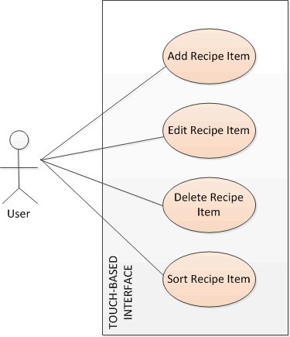
Figure 1. Use Case Diagram of the INTERACTIVE KITCHEN HELPER

For thorough functionality on the HP TouchSmart system, the following design requirements must also be met (HPDevGuidelines):
- Size touch targets correctly.
- Position touch targets correctly.
- Favor touch interaction over input from physical keyboard and mouse input devices.
- Limit the amount of text entry per page.
- Do not define behaviors that require mouse hovers.
- Do not use context or pop-up menus.
- Tasks should be transactional.
- UI elements or controls must automatically scale or size to fit localized content.
- Application must run under 32-bit and 64-bit versions of Windows Vista or later.
- Application must require a parameter to launch in “chromeless” mode.
- Application must support Multilingual User Interface (MUI).

2.2 NON-FUNCTIONAL REQUIREMENTS
As touch-based applications require haptic modes of interaction with controls on touch interfaces, the size of the finger and the size of the respective controls are essential to delivering effective touch applications. Other non-functional requirements are as follows:
- Performance: For touch-based applications that function on a Windows-based platforms, Microsoft Visual Studio Integrated Development Environment is the way to go as WPF or Microsoft Silverlight are recommended tools of app development due to their enhanced UI design and development resources (GeekTieGuy).

SECTION 3

DEVELOPMENT ENVIRONMENT

3.1 SYSTEM ARCHITECTURE
The system architecture of this project is based on a four-tiered one as shown in Figure 2.
The bottom-most layer is the HP Touch-Enabled hardware which serves as the host device for this project. Directly above the hardware is the host operating system of Windows 7 which houses the various system programs and the HP TouchSmart shell. This OS is recommended due to its “Windows Touch” feature which embraces the multi-touch technology. Further up is the HP TouchSmart Environment also known as the “shell” and this allows for the docking and launching of applications native to the system. The topmost layer is the Interactive Kitchen Helper application which is contained within the HP TouchSmart shell and launches from within the shell.

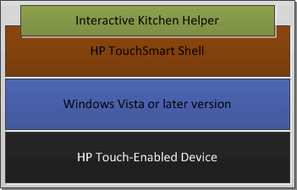
Figure 2. System architecture

3.2 Microsoft Visual Studio IDE
Our application development environment is Microsoft Visual Studio. This is an integrated development environment that can be used to develop console and graphical user interface applications along with windows Forms applications, websites, web apps and web services just to name a few. It allows a code editor, integrated debugger, web designer, class designer and database schema designer as an enhanced app development environment. It also serves as the primary stage for the Interactive Kitchen Helper where coding and initial testing is performed. Microsoft Visual Studio also supports the WPF platform as well as XAML, XML and C# languages to name a few (MicrosoftVisualStudio).

3.2.1 Windows Presentation Foundation (WPF)
WPF is short for Windows Presentation Foundation is a graphical display system for Windows designed for .NET and influenced by modern display technologies such as HTML (Hypertext Markup Language) and Flash. Its display technology is based on two frameworks of the common Windows operating system namely User32 and GDI/GDI+. Underlying the WPF is also a powerful new infrastructure based on DirectX which is the hardware accelerated-graphics API (Application Programming Interface) commonly used in cutting edge computer games. Overall, WPF combines the best of the old world of Windows development with new innovations for building modern, graphically rich user interfaces (WPF).

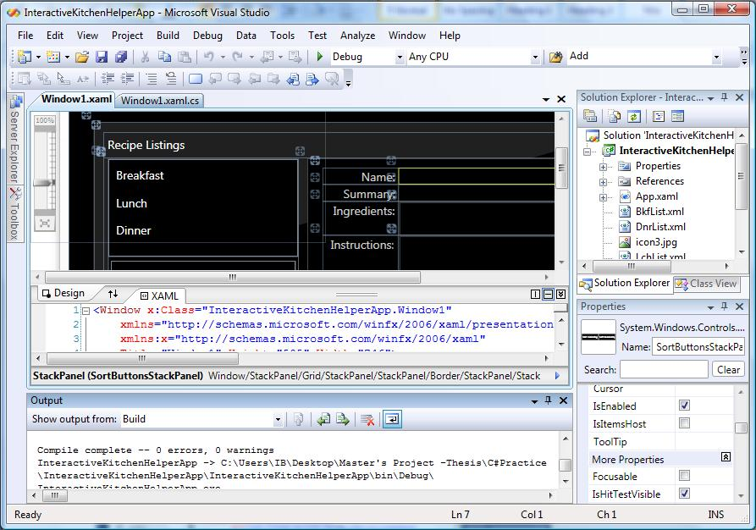
Figure 3. Minimized view of Microsoft Visual Studio IDE

3.2.2 Extensible Markup Language (XML)
Extensible Markup Language is a set of rules for encoding documents in machine-readable form with the design goals emphasizing simplicity and usability over the internet. It is widely used for the representation of arbitrary data structures in web services and contains specifications for constructs within its format denoting Elements, Attributes, Tags, Markup and Content, Processor and Application, and many more. Due to its generality, many APIs have been developed to use in processing XML data and schemas to aid in the definition of XML-based languages (XML).
3.2.3 Extensible Application Markup Language (XAML)
An acronym for Extensible Application Markup Language, XAML is a markup language for declarative application programming applied to the .NET Framework programming model to simplify the process of creating UIs (user interfaces) within the .NET Framework application. Through this paradigm, visible UI elements can be created in the declarative XAML markup and then run-time logic applied separately using code-behind files which are joined to the markup through partial class definitions. Typically within the .NET environment these partial class definitions are applicable via the programming languages of C# and Visual Basic and contain the file extension of .xaml.cs or .xaml.vb respectively while the XAML file simply has the extension of .xaml (XAML).

3.2.4 C Sharp (C#)
This is a programming language developed by Microsoft within the .NET initiative with the intention to be a simple, modern, general-purpose, object-oriented programming language (OOPL). It is a language for use in developing software components suitable for deployment in distributed environments and also within hosted and embedded systems thereby denoting its efficiency in economical use of resource with regard to memory and processing power requirements.

3.3 HP TouchSmart Development Environment (aka the “shell”)
The HP TouchSmart Development environment holds four distinct layouts, the Large Layout, the Wide-Interactive Layout, the Medium Layout and the Small Layout as shown in Figure 4.

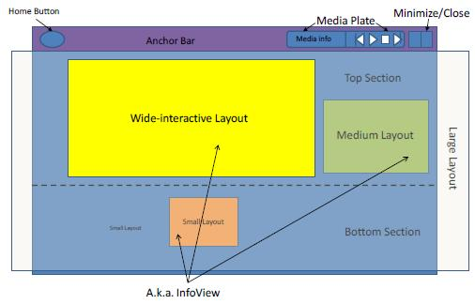
Figure 4. The three distinct layouts of the HP TouchSmart shell

The default view hosts the main window of a hosted application as an InfoView and this InfoView maps to the main window initially associated with the application when its process launches. A minimize or close button is also featured at the top left corner of the screen to allow the hiding of processes or termination of programs.
The Small and Medium Layouts on the main window also called the SmartCenter, contain no controls but serve as auxiliary access tabs to the active processes while the Wide-Interactive and Large Layouts allow user accessibility to controls of their programs.
Within the HP TouchSmart environment, the user is able to move a tile from the bottom section to the top section and vice versa. When a tile is moved from the bottom section, the SmartCenter activates the executable file thereby “launching” the hosting application and positions the InfoView to occupy the entire area and when the tile is moved from the top to the bottom, the executable file is stopped and repositioned to fit the smaller area.

SECTION 4

DESIGN SPECIFICATION AND IMPLEMENTATION

The system design is generally an object-oriented one incorporating the touch interface, the shell, the executable file for the Interactive Kitchen Helper application and its respective data storage xml files. An overview of the systems structure is shown in Figure 5.

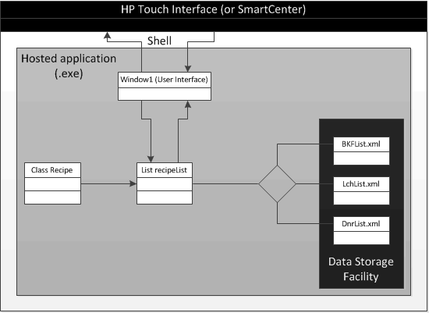
Figure 5. System structure for the Interactive Touch Application

The operational flow of the system in its design acts thus wise. The touch interface receives input and translates it to the hosted application residing within the shell and in this case, the Interactive Kitchen Helper. When the Interactive Kitchen Helper receives the appropriate input, it performs the respective operations of adding, editing, deleting or sorting its recipe items and terminates at the point of origin which is the Window 1, the user interface. These features of the Interactive Kitchen Helper are introduced in Table 1 and further described in the use cases of Tables 2, 3, 4 and 5.

Table 1. Feature description of the INTERACTIVE KITCHEN HELPER
Feature | Description
Add | This allows the user to add new recipe entries into the database for later retrieval.
Edit | The user is able to edit the recipes within the database.
Delete | The user is able to remove any unnecessary recipes from the database.
Sort | This operation simply allows the user to sort recipe items either in ascending or descending alphabetical order.

4.1 SYSTEM FEATURES
From Figure 6, the hosted application is the Interactive Kitchen Helper and is based on the WPF platform. It consists of the user interface (Window 1) which is designed in XAML, the back-end functionality which consists of methods for the application’s operation. A Recipe class which creates recipe instances as items and a recipeList List collection which holds the recipe items are features of the back-end. In addition, three XML files are used as data repositories to store the recipe items from the List collection.

If the operation is an Add Recipe Item operation, the List relies on the Recipe class for the creation of a Recipe object and then adds this object to the List recipeList and if the operation is either an Edit Recipe Item or Delete Recipe Item, the List is manipulated accordingly. In all cases the List is serialized to the appropriate xml files which serve as the system’s database(s) and then deserialized back to the List to be utilized in Window1. Typical to the flow of the Interactive Kitchen Helper, the first screen observed from the launching of the application is its main interface and this is shown in Figure 6.

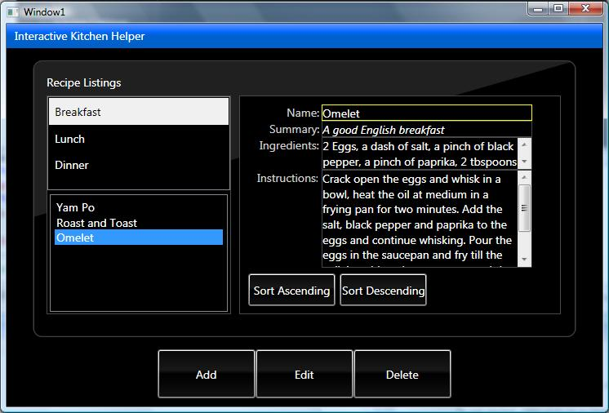
Figure 6. Main interface of the Interactive Kitchen Helper

The main interface primarily consists of two listboxes, five buttons and a textblock amidst other minor controls. Below the first listbox allows for the recipe types to be selected such as “Breakfast”, “Lunch” and “Dinner” while the next listbox displays the recipe items for each selected recipe type (if any have been previously added). The five buttons are “Add”, “Edit”, “Delete”, “Sort Ascending” and “Sort Descending” and are described in Table 1 and further in their respective use cases. There is another interface which becomes visible whenever an “Add’ or “Edit” operation is to be performed. This is the Add-Edit interface and it is shown in Figure 7.

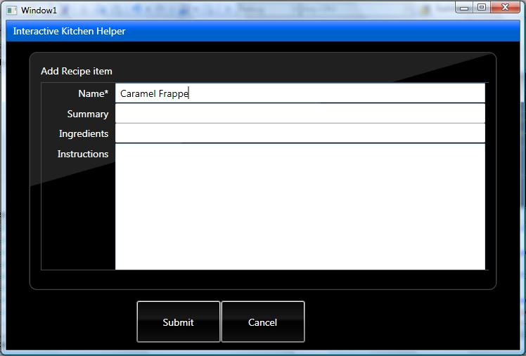
Figure 7. Add-Edit interface of the Interactive Kitchen Helper

This interface consists of three textboxes, one textarea to allow entry of recipe item data and two buttons namely “Submit” and “Cancel”. When the user enters data to either be added or edited and clicks on the Submit button, operations are performed and the screen is switched from the Add-Edit interface to the Main interface symbolizing the completion of the operation. If the Cancel button is clicked, then the operation is not performed but rather the interface is switched to the Main interface.

4.1.1 Add Recipe Item
The Add feature is described in the Add Recipe Item use case of Table 2. This is predicate on the recipe type selection and the activity diagram of Figure 8 depicts this process.

Table 2. Add Recipe Item use case
USE CASE NAME: | Add Recipe Item
ACTOR: | System User
DESCRIPTION: | Describes the procedure when a system user adds a recipe item.
NORMAL COURSE: | - System user selects recipe type (i.e. “Breakfast”, “Lunch” or “Dinner”) from ListBox1 aka “Recipe Listings”.  - User clicks on “Add” button.  - Interface is switched to allow text entry.  - User enters text for recipe item to be added.  - User clicks on “Submit” button.  - New recipe object is created.  - Text entry is used for recipe object properties.  - Recipe object is added to list.  - List is serialized to appropriate xml file.  - Xml file is deserialized back to list.  - Added item is displayed in ListBox2.
ALTERNATE COURSE:
PRECONDITION: | - Application must be initialized and window loaded.  - User must select recipe type from ListBox1.
POST-CONDITION: | Added item is displayed in ListBox2.

To elaborate further, when the Add button is clicked, the system checks to see if a recipe type selection has been made by calling the Boolean function isSelected(). If true is returned, the interface is interchanged to the Add-Edit interface to allow the user enter text that pertains to the recipe item to be added. The Add-Edit interface consists of four text fields of Name, Summary, Ingredients and Instructions and two buttons which are Cancel and Submit. These text fields are made available for text entry as pertains to the recipe item to be added and the Name text field is mandatory to be filled while the others are optional. When the user enters text into the required fields and clicks on the Submit button, the NewAddRecipe() function is called which creates a recipe object from the Recipe class and applies the entered text appropriately as properties of that object. The recipe object is then applied to a List object called recipeList which holds the collection of recipe items. The items in the list are then serialized to an xml file (either Bkflist.xml, Lchlist.xml or Dnrlist.xml) as appropriate which serves as a database through the Serializer() subroutine and in turn deserialized to the List object via the Deserializer() function. The ClearTextBoxEntry() function is called to clear the text from the text boxes within the Add-Edit interface and then the interface is switched back to the Main interface as a result of the subroutine SwitchInterface(). With this done the ListBoxDisplay() function is called to display the items of the List object which includes the added item within ListBox2.

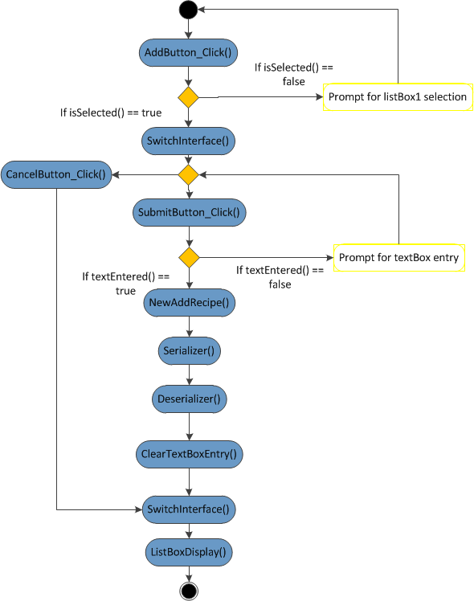
Figure 8. Activity diagram of Add Recipe item operation
4.1.2 Edit Recipe Item
Table 3 is the Edit Recipe Item use case and this is triggered when the system user clicks on the “Edit” button on the Main interface.

Table 3. Edit Recipe item use case
USE CASE NAME: | Edit Recipe Item
ACTOR: | System User
DESCRIPTION: | Describes the procedure when the user decides to edit a recipe item.
NORMAL COURSE: | - System user selects recipe type (i.e. “Breakfast”, “Lunch” or “Dinner”) from ListBox1 aka “Recipe Listings”.  - User selects recipe item to be edited.  - User clicks on “Edit” button.  - Interface is switched to allow text entry.  - User enters text for recipe item to be edited.  - User clicks on “Submit” button.  - Recipe item is searched for within the (appropriate) list.  - When found list item is edited as appropriate.  - List is serialized to (appropriate) xml file.  - Xml file is deserialized back to list.  - Edited item is displayed in ListBox2.
ALTERNATE COURSE:
PRECONDITION: | - Application must be initialized and window loaded.  - User must select recipe type from ListBox1.
POST-CONDITION: | Edited item is displayed in ListBox2.

The Activity diagram of Figure 9 depicts the flow of the operations from when the Edit button is clicked. As seen in the aforementioned figure, the function EditButton_Click() is initialized when the “Edit” button is clicked and the boolean function isSelected() is called to verify if a recipe type has been selected. If true is returned, the systems checks for the recipe item selection in the second listbox and if that has been selected, the Main interface is switched to the Add-Edit interface. From this standpoint, the operation proceeds similar to that of Add Recipe Item however the difference is in the subroutines called. Here the subroutine of NewEditRecipe() is called where it searches the List for the editable Recipe instance.

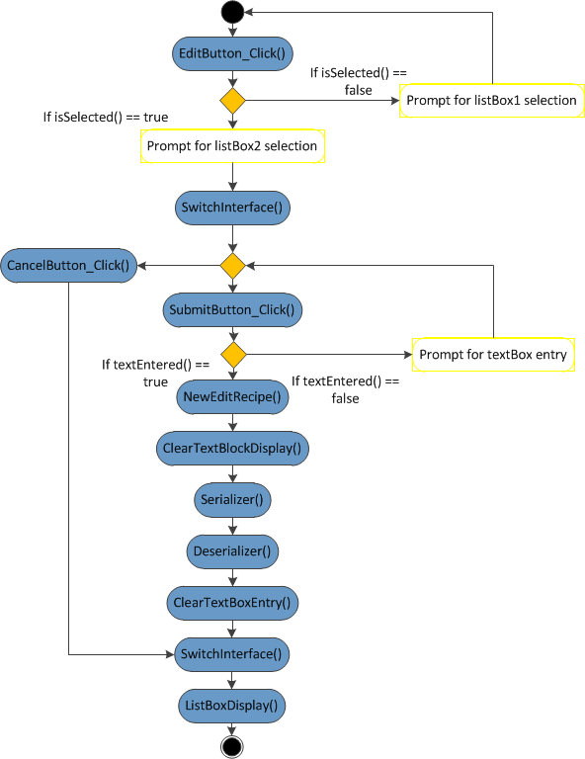
Figure 9. Activity diagram of Edit Recipe item operation

4.1.3 Delete Recipe Item
The “Delete Recipe Item” use case is shown below in Table 4 and this operation is initialized by the “Delete” button on the Main interface.

Table 4. Delete Recipe item use case
USE CASE NAME: | Delete Recipe Item
ACTOR: | System User
DESCRIPTION: | Describes the procedure when the user decides to delete a recipe item.
NORMAL COURSE: | - System user selects recipe type (i.e. “Breakfast”, “Lunch” or “Dinner”) from recipe listing.  - Recipe items are displayed.  - User selects recipe item to delete.  - User clicks on the “Delete” button.  - Recipe item is searched for within (appropriate) list.  - Item is deleted from list.  - List is serialized to xml file.  - Xml is deserialized back to list.  - List items are displayed in ListBox2.
ALTERNATE COURSE:
PRECONDITION: | - Application must be initialized and window loaded.  - Recipe item must have already been added or xml file must contain recipe items.  - ListBox2 must show recipe item.
POST-CONDITION: | List Box item are displayed in ListBox2.

This operation is predicate on the selection of the recipe type and that of the recipe item. Once the system confirms the selection of these properties, the NewDeleteRecipe() subroutine is called where the List is searched for the particular Recipe instance that matches the selection and then the process follows that of the Add and Edit Recipe Item’s and the following activity diagram of Figure 10 depicts this.

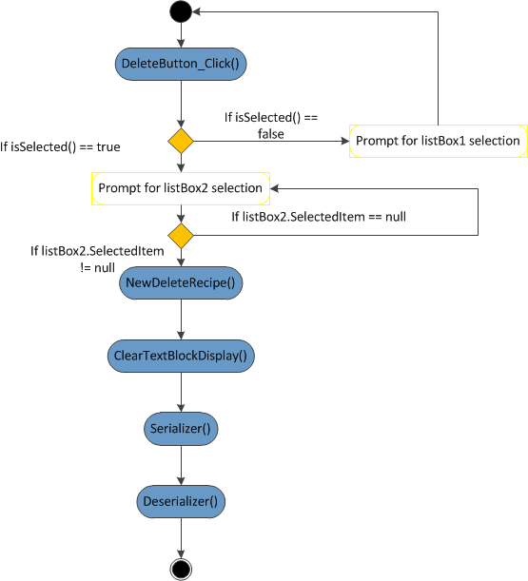
Figure 10. Activity diagram of Delete Recipe item operation

4.1.4 Sort Recipe Item
The use case of Table 5 elaborates on the Sort Recipe items operation. “Sort Ascending” and “Sort Descending” buttons are made visible when the recipe type is selected and only if there exists more than one recipe item in the List recipeList (see Figure 11).

Table 5. Sort Recipe items use case
USE CASE NAME: | Sort Recipe Items
ACTOR: | System User
DESCRIPTION: | This describes the procedure when the user decides to sort the recipe items.
NORMAL COURSE: | - User selects recipe type (i.e. “Breakfast”, “Lunch” or “Dinner”) from recipe listing.  - Recipe items are displayed in ListBox2.  - User clicks on either “Sort Ascending” or “Sort Descending” button.  - Recipe items are sorted and displayed within ListBox2.
ALTERNATE COURSE:
PRECONDITION: | - Application must be initialized and window loaded.  - List Box2 must contain more than one recipe item.
POST-CONDITION: | Recipe items are sorted and displayed within ListBox2.

In such a case, the boolean isSelected() function is verified and if it returns true, the appropriate Sort subroutine is called and therefore either SortAscending_Click() or SortDescending_Click(). Finally the sorted recipe types are displayed via the ListBoxDisplay() function.

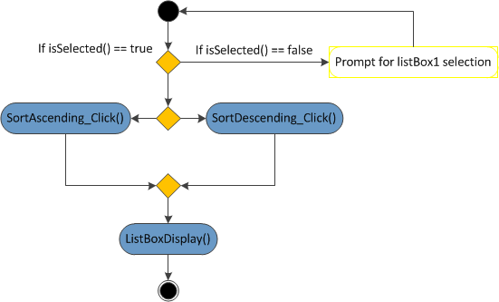
Figure 11. Activity diagram of Sort Recipe items operation

4.2 System Integration
Having designed the hosted application, Interactive Kitchen Helper, the implementation phase comprised of integrating this app into the shell of the hosting application, namely SmartCenter. To do this, the hosted application must proceed with the following steps to ensure smooth transition into the shell:
- The XAML file of Window 1must be edited to match the code below so as to allow the application launch without a window frame and also to position it appropriately:
<Window
xmlns="http://schemas.microsoft.com/winfx/2006/xaml/presentation"
xmlns:x="http://schemas.microsoft.com/winfx/2006/xaml"
Title="Interactive Kitchen Helper"
Top="{Binding Source={x:Static SystemParameters.VirtualScreenHeight}}"
Left="{Binding Source={x:Static SystemParameters.VirtualScreenWidth}}"
Background="Black"
ShowInTaskbar="False"
WindowStyle="None"
ResizeMode="NoResize">

- Then the application must be registered to allow it to be launched from within the shell aka SmartCenter.
  - To do so, we created an xml file called register.xml with the following parameters:
<AppManagementSetting>
<UserEditable>true</UserEditable>
<RunAtStartup>true</RunAtStartup>
<RemoveFromTaskbar>false</RemoveFromTaskbar>
<AppPath>C:\Hewlett-Packard\TouchSmart\InteractiveKitchenHelper\InteractiveKitchenHelper\bin\Debug\InteractiveKitchenHelper.exe</AppPath>
<AppParameters>chromeless</AppParameters>
<AllowAttach>true</AllowAttach>
<Section>Top</Section>
<Type>InfoView</Type>
<DisplayName>InteractiveKitchenHelper</DisplayName>
<IsVisible>true</IsVisible>
<UserDeleted>false</UserDeleted>
<InDefaultSet>false</InDefaultSet>
<IconName />
</AppManagementSetting>

**Note: The tag “AppPath” must not have any Carriage Line Return Feeder” included and therefore must be all on the same line else the application may not register properly.

  - With the register.xml file created, we then proceed with the registration using the following steps from the command line prompt:
    - Change the directory to where the SmartCenter is located primarily for the RegisterSmartCenterapp.exe file and in this case, C:\Program Files\Hewlett-Packard\TouchSmart\SmartCenter2.0
    - Then we enter the following command
RegisterSmartCenterApp.exe updateconfig [%the path to our hosted application’s executable file%]

Upon completion of these aforementioned steps and if done correctly, a congratulatory message is received and a confirmation of our application within the Small Layout of the Smart Center can be verified as well as launched. Registering the Interactive Kitchen Helper within the HP TouchSmart shell is required for the application to be launched from within the shell but with a sleight of code concerning the register.xml and the CLRF – Carriage Line Return Feeder noted in Section 5.1 under steps 2a, although a registration confirmation of the application may be received, the application may not be added to the user.config file and therefore pose a limitation to its launching. As a caution, the tag “AppPath” within the register.xml file must not contain any CLRF but must have the entire tags from opening to closing on the same line for the registration to proceed unhinged.

SECTION 5
CONCLUSIONS AND FUTURE WORK

In conclusion, there are many improvements that can be made to the existing system. These include, enhancements of the user interface to include multi-touch gestures, adaptation of the system to meet the various screen-sizes, applying the notification mechanisms for enhanced operations that function alongside the executable file and improving the overall design of the application. The aesthetics of touch-based interfaces is also notable and should be given serious consideration with regards to finger size and UI controls.

During the system design, obtaining real time updates from the xml files posed an issue. This was due to the data binding which was performed from the front end via XAML. In latter findings, data binding for real time updates is best done via the back end in C# code. Currently, the user interface design is one that is tailored to fit a specific screen dimension and not universal to all TouchSmart systems. This pertains to the fact that the application development was conducted on a device other than the HP TouchSmart and integration testing later performed on the HP TouchSmart device yielded limitations in the design that affected the display of the application. Therefore to accentuate the application’s design would be to improve that of the user interface, enhance the application with multi-touch gestures and apply system notification mechanisms to communicate with the hosting application. Irregardless, of these trade-offs, it is safe to declare that the objectives of designing, developing and deploying an interactive touch application on the HP TouchSmart system was achieved and its design can be enhanced and optimized in future work.
REFERENCES

C Sharp (programming language). (2011). Retrieved from Wikipedia: http://en.wikipedia.org/wiki/C_Sharp_(programming_language)#cite_note-ECMA-334-6

GeekTieGuy. (2009). HP TouchSmart application development in a nutshell. Retrieved from http://www.geektieguy.com/2009/09/24/hp-touchsmart-application-development-in-a-nutshell/

MacDonald, M. (2008). Pro WPF in C# 2008: Windows Presentation Foundation with .NET 3.5 (2nd Edition). Berkeley: Apress.

HP TouchSmart SDK Development Documentation Hosted Application Development Guidelines Version 3.0

XAML Overview (WPF). (2011). Retrieved from Microsoft Developer Network: http;//msdn.microsoft.com/en-us/library/ms752059.aspx

XML. (2011). Retrieved from Wikipedia: http://en.wikipedia.ord/wiki/XML

